**EXERCISE: 01**

**DATE: 23.11.2020**

**AIM:**

To write a python program to print the calendar of a given month and year

**PROGRAM:**

import calendar as cal

year=int(input())

month=int(input())

if(year>999 and year<10000):

if(month>=1 and month<=12):

print(cal.month(year,month))

else:

print("Invalid Input")

else:

print("Invalid Input")

**LINK:**

<http://103.53.53.18/mod/vpl/forms/edit.php?id=229&userid=1664>

**OUTPUT:**

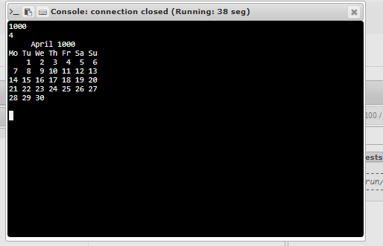

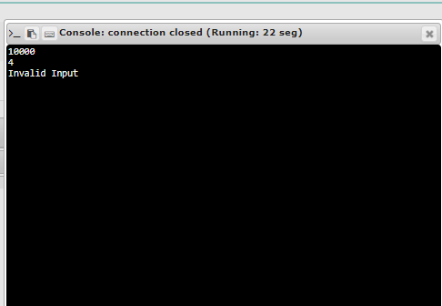

**RESULT:**

Thus the program is executed successfully